SE212 Database System and Design
Lab 8: DDL and DML (20 points)

Name Thanwisit Angsachon SID 682115018
In this lab you will practise the two halves of SQL you have learned in Lecture 7 and 7.1:
- DDL (Data Definition Language): CREATE DATABASE, CREATE TABLE, DROP
- DML (Data Manipulation Language): INSERT, UPDATE, DELETE, SELECT
You need a MySQL server and MySQL Workbench installed (see Before the lab below). Save every statement you write in one file named Lab8_<SID>.sql so you can re-run it.

Before the lab: install the software
You need two things: a MySQL server running on your machine, and MySQL Workbench to write and run SQL. Pick Option A (recommended) or Option B. Lab PCs already have the software installed, skip to Part 1.

Option A: MySQL Community Server + MySQL Workbench (recommended)
A1. Download MySQL Community Server. Go to https://dev.mysql.com/downloads/mysql/, choose your operating system, and download the installer.
- Windows: choose Windows (x86, 64-bit), MSI Installer. Either MSI size works; the larger one works offline.
- macOS: choose the DMG Archive. Pick ARM for Apple Silicon (M1/M2/M3/M4) or x86 for Intel Macs.
- On the next page click “No thanks, just start my download.” You do not need an Oracle account.
A2. Install the server. Run the installer and accept the defaults (Typical / Developer Default). When asked for a root password, choose one and write it down. Keep Start MySQL Server at System Startup ticked. Leave the port at 3306.
A3. Download and install MySQL Workbench from https://dev.mysql.com/downloads/workbe nch/. Choose your OS, click Download, then “No thanks, just start my download.” Run the installer with defaults. On Windows, if the installer asks for Visual C++ Redistributable, install it from the link it gives and re-run.
A4. Test it. Open MySQL Workbench. Under MySQL Connections you should see Local instance MySQL80 (or similar). Click it, enter your root password, and you should get a query editor. Run:
SELECT VERSION();
If you get a version number (8.x), you are ready.

Option B: XAMPP (if you already use it, or Option A fails)
B1. Download XAMPP from https://www.apachefriends.org/download.html. Choose the version for your OS (any PHP version is fine) and run the installer with defaults. On Windows, install to C:\xampp.
B2. Start the database. Open the XAMPP Control Panel and click Start next to MySQL. It should turn green and show port 3306. You do not need Apache for this lab.
B3. Install MySQL Workbench as in step A3 above. XAMPP ships MariaDB rather than MySQL, so Workbench may show a warning about an unsupported server version. Click Continue Anyway.
B4. Connect. In Workbench click + next to MySQL Connections, name it xampp, host 127.0.0.1, port 3306, user root, password empty. Click Test Connection, then OK.
B5. Command line with XAMPP. The mysql client is at C:\xampp\mysql\bin\mysql.exe. In Command Prompt, run cd C:\xampp\mysql\bin first, then use mysql -u root (no -p) in the commands in Part 2.
MySQL root password. Every command in this lab logs in as root.
  - Your own laptop: use the password you chose when you installed MySQL Server.
  - Lab PC: the TA will write the root password on the board:
  - XAMPP: the root password is empty. Leave out -p, e.g. mysql -u root, and in Workbench leave the password blank.
If none of these work on a lab PC, tell the TA. Do not try to reset the password on a shared machine.
Submission: see the Submission checklist on the last page before you upload anything to Mango.

Part 1: University database (12 points)
A small university wants to record students, the courses it offers, the sections of each course that run in a given semester, and which students are enrolled in which sections. The four relations are given below. Underlined attributes are primary keys. -> shows a foreign key and the table it references.

Relational schema
STUDENT (student_id, first_name, last_name, email, birth_date, major)

Attribute | Type | Constraint
student_id | INT | PRIMARY KEY
first_name | VARCHAR(50) | NOT NULL
last_name | VARCHAR(50) | NOT NULL
email | VARCHAR(100) | NOT NULL, UNIQUE
birth_date | DATE
major | VARCHAR(50)

COURSE (course_id, course_name, credits, department)

Attribute | Type | Constraint
course_id | CHAR(6) | PRIMARY KEY
course_name | VARCHAR(100) | NOT NULL
credits | INT | NOT NULL, CHECK (credits BETWEEN 1 AND 4)
department | VARCHAR(50) | NOT NULL

SECTION (section_id, course_id -> COURSE, semester, year, instructor_name, room)

Attribute | Type | Constraint
section_id | INT | PRIMARY KEY, AUTO_INCREMENT
course_id | CHAR(6) | NOT NULL, FK -> COURSE(course_id)
semester | INT | NOT NULL (1 or 2)
year | INT | NOT NULL
instructor_name | VARCHAR(100) | NOT NULL
room | VARCHAR(20)

ENROLLMENT (student_id -> STUDENT, section_id -> SECTION, enroll_date, grade)

Attribute | Type | Constraint
student_id | INT | FK -> STUDENT(student_id)
section_id | INT | FK -> SECTION(section_id)
enroll_date | DATE | NOT NULL
grade | CHAR(2) | NULL allowed (A, B+, B, C+, C, D+, D, F)
(student_id, section_id) |  | composite PRIMARY KEY

Tasks
  - (3 points) DDL. Write and run the statements to create a database called se212_university and the four tables above. Put every constraint from the tables into your CREATE TABLE statements (primary keys, foreign keys, NOT NULL, UNIQUE, CHECK). Create the tables in an order that does not break any foreign key.
Hint: start with DROP DATABASE IF EXISTS se212_university; so your script can be re-run from the top.
  - (4 points) INSERT. Insert the following rows. Insert them in the correct table order.
Note: all student names, IDs, emails and instructor names below are made up for this exercise. They do not belong to real people.
STUDENT

student_id first_name | last_name | email | birth_date | major
640110001 Nattapong | Srisuwan | nattapong.s@cmu.ac.th | 2004-03-12 | SE

student_id | first_name |  | last_name |  | email |  |  | birth_date |  | major
640110002 | Kanokwan |  | Chaiyasit |  | kanokwan.c@cmu.ac.th |  |  | 2003-11-30 |  | SE
640110003 | Peeraphat |  | Wongsa |  | peeraphat.w@cmu.ac.th |  |  | 2004-07-08 |  | MMIT
COURSE
course_id | course_name |  |  |  |  |  |  | credits | department
953212 | Database System and Database System Design |  |  |  |  |  |  | 3 | SE
953211 | Software Engineering Fundamentals |  |  |  |  |  |  | 3 | SE
SECTION (let section_id auto-increment)
 |  | course_id | semester | year | instructor_name room
 |  | 953212 | 1 | 2026 | Pree Thiengburanathum CAMT 413
 |  | 953211 | 1 | 2026 | Somchai Jaidee CAMT 212
ENROLLMENT
 |  |  | student_id | section_id |  | enroll_date | grade
 |  |  | 640110001 | 1 |  | 2026-06-15 | NULL
 |  |  | 640110002 | 1 |  | 2026-06-15 | NULL
 |  |  | 640110003 | 1 |  | 2026-06-16 | NULL
 |  |  | 640110001 | 2 |  | 2026-06-15 | NULL

After inserting, run SELECT * FROM enrollment; and take a screenshot (S1) of the result grid in Workbench.
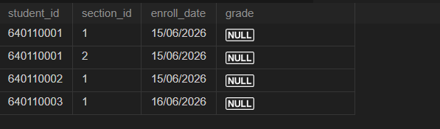

(2 points) UPDATE and DELETE.
    - Student 640110001 finished section 1 with grade B+. Write the UPDATE statement.
    - Student 640110003 dropped section 1. Write the DELETE statement that removes only that enrollment.
  - (3 points) Short answers. Write your answers below or as comments in your .sql file.
    - Why must COURSE be created before SECTION, and STUDENT and SECTION before ENROLLMENT?

= Because there are keys that those latter created tables need to refer to (foreign keys) in the prior created tables, so when writing the code, if you didn’t define the prior tables, it cannot find those keys to refer to. (Code executes sequentially.)

    - Try DELETE FROM section WHERE section_id = 1; What message does MySQL give and why? Which constraint stops it?
= OK, 3 rows affected in 1.796ms
Which means, all the row with section_id = 1 are deleted, no one is enrolled in that course anymore. So, we need to check for the student_id as well, in order to only remove 1 student from the course, it stops everyone else from being removed too.

    - Try to insert a course with credits = 5. What happens and which constraint is responsible?
= MySQL Error (3819): Check constraint 'course_chk_1' is violated.
This constraint is responsible
…
credits int not null
check(
credits between 1 and 4
),
…

Take a screenshot (S2) of the se212_university schema tree in the Workbench Navigator with all four tables expanded.

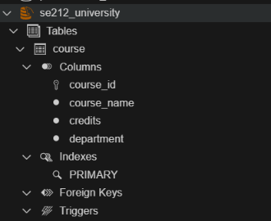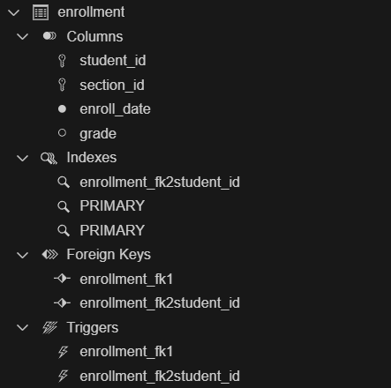

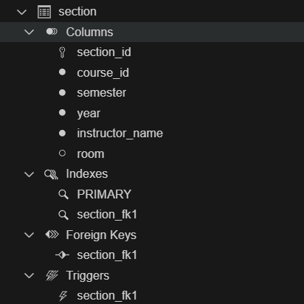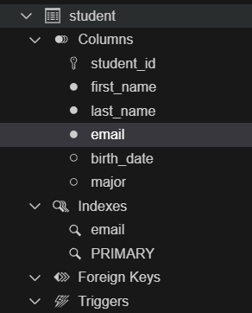

Part 2: Install the Murach sample databases (8 points)
For the rest of the SQL labs we will use the three sample databases from Murach’s MySQL: ap_extra (accounts payable), ex (examples) and om (order management). One script creates all of them.

Get the files
Download Lab8.zip from Mango and extract it. Inside you will find this sheet and a Lab8_murach
folder:
Lab8/
Lab8.pdf Lab8_murach/
create_databases.sql <- creates ap_extra, ex, om ER-diagram-APdatabase-Murach.pdf
ER-diagram-APdatabaseW2ExtraTables-Murach.pdf ER-diagram-EXdatabase-Murach.pdf
ER-diagram-OMdatabase-Murach.pdf

Install from the command line

Step 1. Open a terminal.
    - Windows: press Win + R, type cmd, press Enter. If mysql is not recognised, use MySQL 8.x Command Line Client from the Start menu instead and skip to Step 3.
    - macOS: open Terminal. If mysql is not found, run export PATH=$PATH:/usr/local/mysql/bin
first.
Step 2. Change into the folder where you extracted the zip. Example:
cd C:\Users\<you>\Downloads\Lab8\Lab8_murach
Step 3. Run the script. Type the command below, then enter the root password you set when installing MySQL.
mysql -u root -p < create_databases.sql
If you are in the MySQL Command Line Client (already logged in), use the source command with the full path instead:
source C:/Users/<you>/Downloads/Lab8/Lab8_murach/create_databases.sql
The script takes a few seconds. No output means success. If you see ERROR 1045 (28000): Access denied, the password is wrong; if you see ERROR 2003 (HY000): Can't connect, the MySQL server is not running (start it from Services or System Preferences).
Step 4. Verify. Log in and check the databases exist:
mysql -u root -p SHOW DATABASES;
USE ap_extra; SHOW TABLES; USE ex; SHOW TABLES;
USE om; SHOW TABLES;
exit
You should see 7 tables in ap_extra, 11 in ex, and 4 in om.
Workbench alternative. If the command line does not work: open MySQL Workbench, connect, choose File > Open SQL Script. . . , pick create_databases.sql, then click the

lightning-bolt Execute button. Right-click in the Navigator and choose Refresh All to see the new schemas.

Tasks
  - (2 points). In Workbench, expand the om schema and its four tables in the Navigator. Take a screenshot (S3). Open ER-diagram-OMdatabase-Murach.pdf and check that the foreign keys in the diagram match the tables.
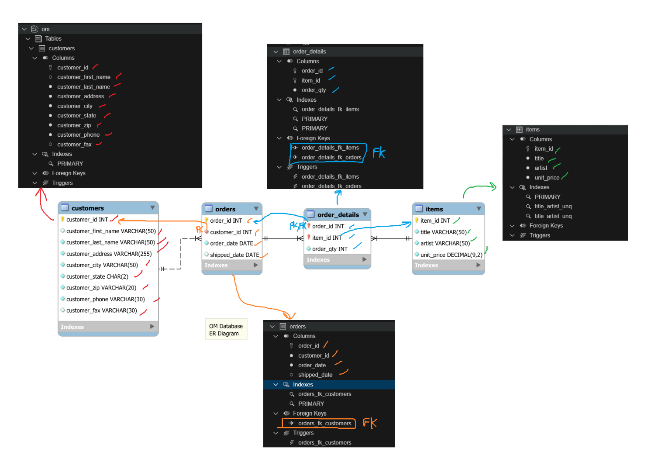
  - (3 points). Using the ap_extra database, list the vendor name, city and phone of every vendor located in the state NJ, ordered by vendor name. Write the statement and note how many rows are returned.

use ap_extra;
select vendor_name, vendor_city, vendor_phone from vendors
where vendor_state = 'NJ' ORDER BY vendor_name ASC;

Rows returned: 4
  - (3 points). Using the om database, show each customer’s last name together with the number of orders they have placed. Show customers with the most orders first. Write the statement and note the top customer.

use om;
select orders.customer_id, customers.customer_last_name, count(orders.order_id) as number_of_orders
from orders RIGHT join customers on customers.customer_id = orders.customer_id
group by customers.customer_id ORDER BY number_of_orders DESC;

Top customer and order count: Customer with last name Jacobsen who has 6 orders

Submission checklist (read this before you upload)
Submit on Mango (CMU Canvas), assignment Lab 8, before the deadline shown there. This is individual work. Upload exactly two files, named with your student ID:

File 1: Lab8_<SID>.sql
One plain-text SQL script that the TA can run from top to bottom on a clean MySQL server without any error. Use this order and these comment headers so the TA can find each part:
-- Lab 8 | Name: <your name> | SID: <your SID>

-- ===== 1.1 DDL =====
DROP DATABASE IF EXISTS se212_university;
CREATE DATABASE se212_university;
USE se212_university;
-- CREATE TABLE statements here

-- ===== 1.2 INSERT =====
-- INSERT statements here

-- ===== 1.3 UPDATE / DELETE =====
-- UPDATE and DELETE statements here

-- ===== 1.4 Short answers =====
-- 1.4a: <your answer>
-- 1.4b: <your answer>
-- 1.4c: <your answer>

-- ===== 2.2 Vendors in NJ ===== USE ap_extra;
-- SELECT here
-- rows returned: <number>

-- ===== 2.3 Orders per customer ===== USE om;
-- SELECT here
-- top customer: <last name>, <count> orders

File 2: Lab8_<SID>_screenshots.pdf
One PDF (or three PNG files named S1.png, S2.png, S3.png) containing:

Screenshot What it must show From task

S1 Workbench result grid of SELECT * FROM enrollment; with 4 rows
S2 Workbench Navigator: se212_university schema with student, course, section, enrollment expanded
1.2

1.4

Screenshot What it must show From task

S3 Workbench Navigator: om schema with customers, items, order_details, orders expanded
2.1

Each screenshot must show the whole Workbench window (not a cropped grid) so the connection name and schema tree are visible.

How you will be graded
Item | The TA checks | Evidence | Points
1.1 | Database + 4 tables created; PK,  UNIQUE, CHECK all present; | File 1, section 1.1 | 3
1.2 | All 11 rows inserted, correct order, | File 1, section 1.2 + S1 | 4
1.3 | UPDATE and DELETE each affect | File 1, section 1.3 | 2
1.4 | Three short answers, correct and | File 1, section 1.4 | 3
2.1 | Murach databases installed | S3 | 2
2.2 | Correct SELECT, WHERE, | File 1, section 2.2 | 3
2.3 | Correct JOIN, GROUP BY,  customer stated | File 1, section 2.3 | 3
 | Total |  | 20

FK, composite PK, NOT NULL, tables in FK-safe order section_id auto-generated exactly one row
explained

ORDER BY; row count stated COUNT, ORDER BY DESC; top

Deductions. Script stops with an error: the TA grades only the parts that ran before the error. Wrong file names or missing SID: -1. Missing screenshot: 0 for that item. Submitted after the deadline: as per course syllabus.

